**Use Case Diagram**

Use case diagram exhibits the graphic representation iLearnCentral’s process and

possible sequences of interactions between systems and users.

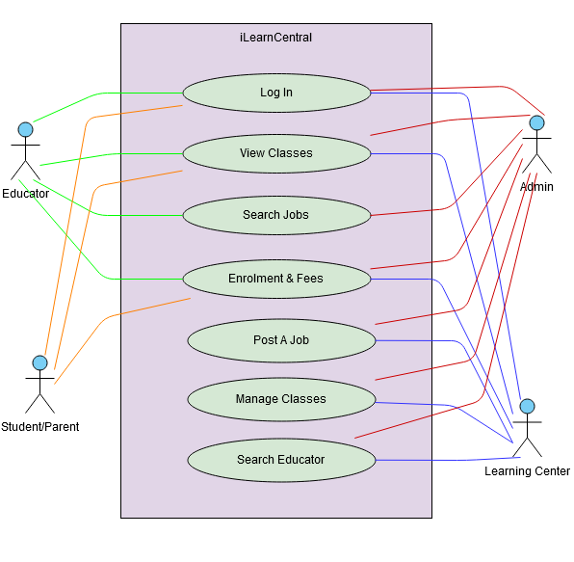

**Network Model**

The network model shows how the components of the system communicates through the internet. The diagram shows that the user can check and monitor their account from both the web and mobile app.

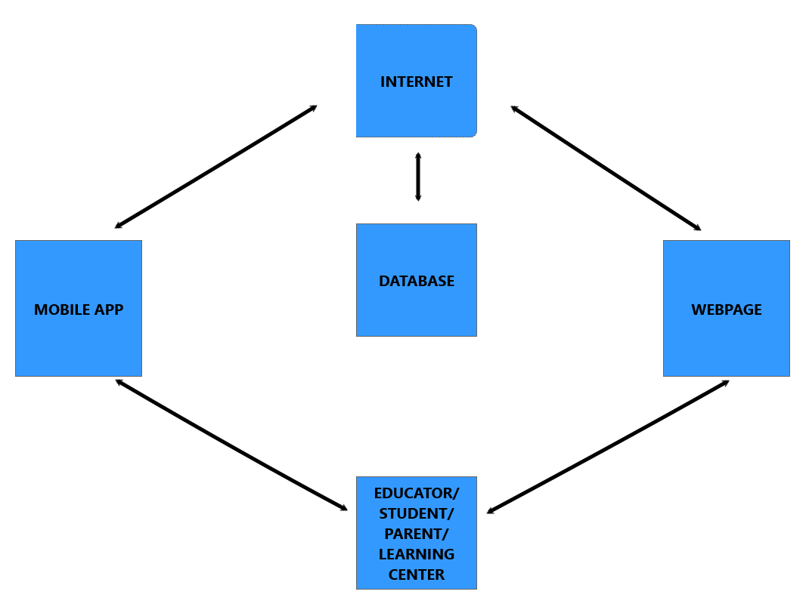

Figure 24 : **Network Model**

Figure 24 shows the network model of the system. Internet is used for both web and mobile app to interact with the database.

**Network Topology**

The network topology shows how both the web and the mobile app work with the use of internet connection.

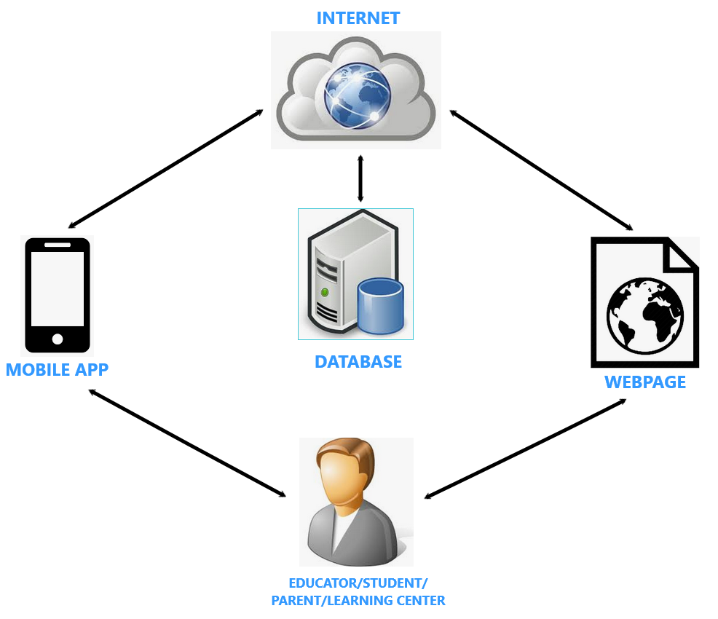

Figure 25: **Network Topology**

Figure 25 shows the network topology of the system. As shown the user can use both web and mobile app with the help of the internet. They can manage classes, check schedules, post and search jobs, etc..